Supply Chain Management
Institution affiliation
Course Title
Date

INTRODUCTION
Supply chain deals with different kinds of organizations which are distributors of raw materials, producers, logistics delivery stations, retail businesses and transportation. These activities occur at different levels which impacts the quality of the outcome of specific procedures in supply chain. Every activity in the supply chain process is important hence the managers in each stage should ensure that the end product is of quality to satisfy the customer’s needs. Supply chain should adopt the quality management framework which is a process that identifies and achieves the activities which an organization need to meet its objectives. The principle of quality management leads to equalization and coordination of the value of all the activities involved in the supply chain organizations.
SUPPLY CHAIN
Supply chain is a composite incorporation of distribution of raw materials producers, suppliers and retailers for the aim of production and supply of goods and services in the right amount, at the right place and time, with the aim of harmonizing demand and supply. SC has two approaches, traditional and modern (Monczka, 2010).
TRADITIONAL APPROACH
This approach summarizes SC as a one-way movement that starts with raw material procurement to the production, to the supply and trade of end products to consumers. Figure 1 below shows the processes that take place in the traditional supply chain approach.
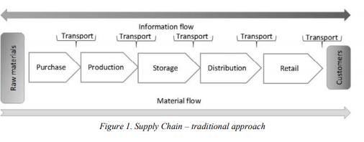
MODERN APPROACH
This approach differs from the traditional approach in that it has a feedback response such that it does not end with the waste disposal. In this approach waste products are recycled and those can’t be recycled are disposed in an environmentally friendly manner. Figure 2 below shows all the processes involved in the modern approach.
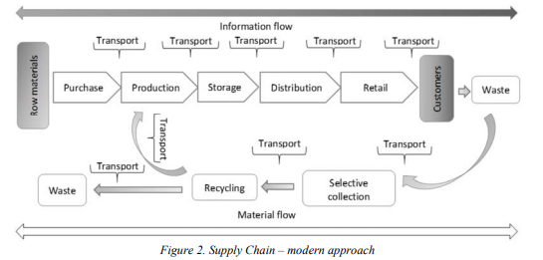

3. QUALITY MANAGEMENT PRINCIPLES
International Standard ISO 9000:2015 is founded on principle of value chain management and its importance to an organization (Juran). The quality management principles include;
- Process approach: a preferred outcome is met more effectively when associated assets and activities accomplished in a process.
- Customer focus: business establishments rely on their customers and hence should understand their needs in order to meet them fully and surpass their desires.
- Evidence-based decision making: data and information obtained helps in making effective decision making.
- Leadership: leaders are in charge of the effective running of an organization. They also create an interior working environment whereby people together towards achieving a common objective.
- Relationship management: a healthy relationship should be maintained between organization and its distributors.
- Engagement of people: workers at different levels of organization management are the heart of organization such that their collective works contribute to the benefit of organization.
- Improvement: the main aim of an organization should be maintain constant improvement.

4. SUPPLY CHAIN IN THE CONTEXT OF QUALITY MANAGEMENT PRINCIPLES.
Table 1 below shows the summary of the difference between supply chains modern and traditional approaches which focuses on waste management.
SC- TRADITIONAL APPROACH | SC-MODERN APPROACH
Raw material procurement process | Raw material procurement process
Manufacturing process | Manufacturing process
Storage process | Storage process
Supply process | Supply process
Transportation process | Transportation process
 | Waste management process

The waste management involves the following processes; selective collection of waste, reusing and correct environmentally friendly disposal of waste. This factor is vital since it determines the importance of modern approach in maintainable development and also increase the amount of quality requirements. Waste management process produces feedback such that it should be applicable to quality management principles. Supply management consist of the environmental management system and quality management system as evident in the feedback management whereby quality management principles is applicable in all the supply chain activities as shown in figure 3 below.
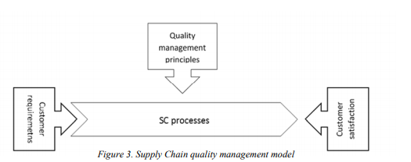
5. CONCLUSION
It is essential to match the quality management system in the organization of all the contributors of supply chain so as to attain greater levels of supply chain since the management systems in an organization are combined. Supply chain is essential to the economy of any country because it explains information, monetary flow and material. The supply chain process should be carried out with great accuracy so as to avoid disruption of any process which can lead to disturbance of supply chain goal. This means that supply chain is essential as it maintains the basic laws of economy that entails demand and supply.

Reference
Drljača, M.; Grgurević, D.: Supply Chain in the Context of Circular Economy. International
Emerald Insight, Bingley, UK, 2014, pp. 1023-1040.
Industry in Digital Age, University of Zagreb, Faculty of Transport and Traffic Sciences, 10-11
industry: A cluster analysis approach. Benchmarking: An International Journal, Vol. 21, No. 6,
June 2018, Opatija, Hrvatska; Ed. Bajor, I.; Vidović, A.; ISSN 2623-5781, pp. 85-92.
Juran, J. M,; The Quality Trilogy: A Universal Approach to Managing for Quality, Quality Progress, Vol. 19, No. 8, 1986., pp. 19.
konferencije Perspektive trgovine, Ekonomski fakultet u Zagrebu, Zagreb, 2013, pp. 215-228.
Monczka et al.: Purchasing & Supply Chain Management, Twente, 2010.
Pupavac, D.; Cross-docking u lancima opskrbe, Zbornik radova međunarodne znanstvene
Satyendra, K. S.; Bhat, A.; Supply chain risk management dimensions in Indian automobile
Scientific Conference ZIRP 2018, Science and Traffic Development, Transport and Logistics
Standard ISO 9001:2015: Quality management systems – Requirements.

